***C0413 Custom Event Business Opportunity / Sales Quotation to Customer Order***

|  |  |  |  |  |
| --- | --- | --- | --- | --- |
| **Ver** | **Date** | **Author** | **Comments** | **Reviewed by** |
| 1 | 09/12/2020 | Linzi Evans |  | TBC |
|  |  |  |  |  |

Requirements 2

Prerequisites 2

Solution Overview 2

Solution Details 2

Security 3

Companies 3

Data Migration 3

Test Steps 3

Technical Implementation 3

Requirements

Custom Event (Pop Up Box) to remind users to add a PO Number in the following instances:

* Create Order from Quotation
* Create Order from Business Opportunity

The Customer PO Number field to be mandatory for all users with a sales / managed services base profile.

Prerequisites

N/A

Solution Overview

When converting a sales quotation to a customer order, a pop-up dialogue box appears. The Customers PO No. field is to be mandatory for site 2012, for all users with a sales profile however, it is not possible to make a dialogue field mandatory. Therefore, a custom event is required on the Customer Order screen.

Solution Details

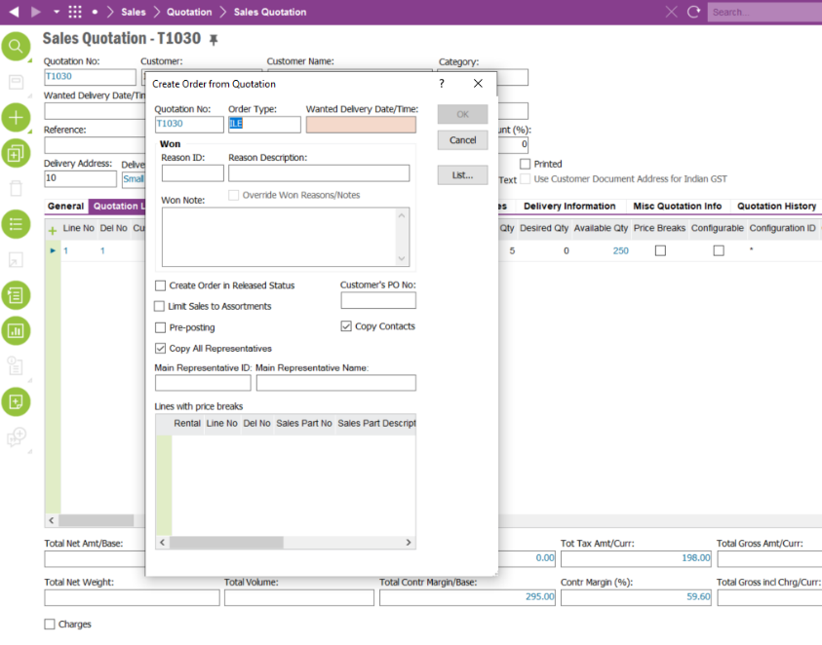

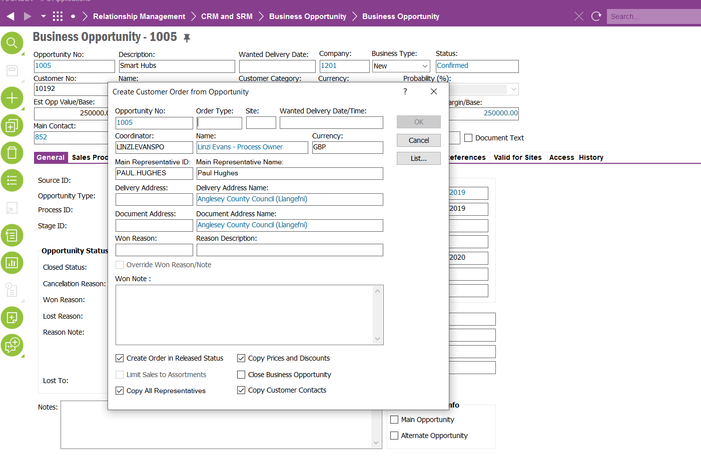 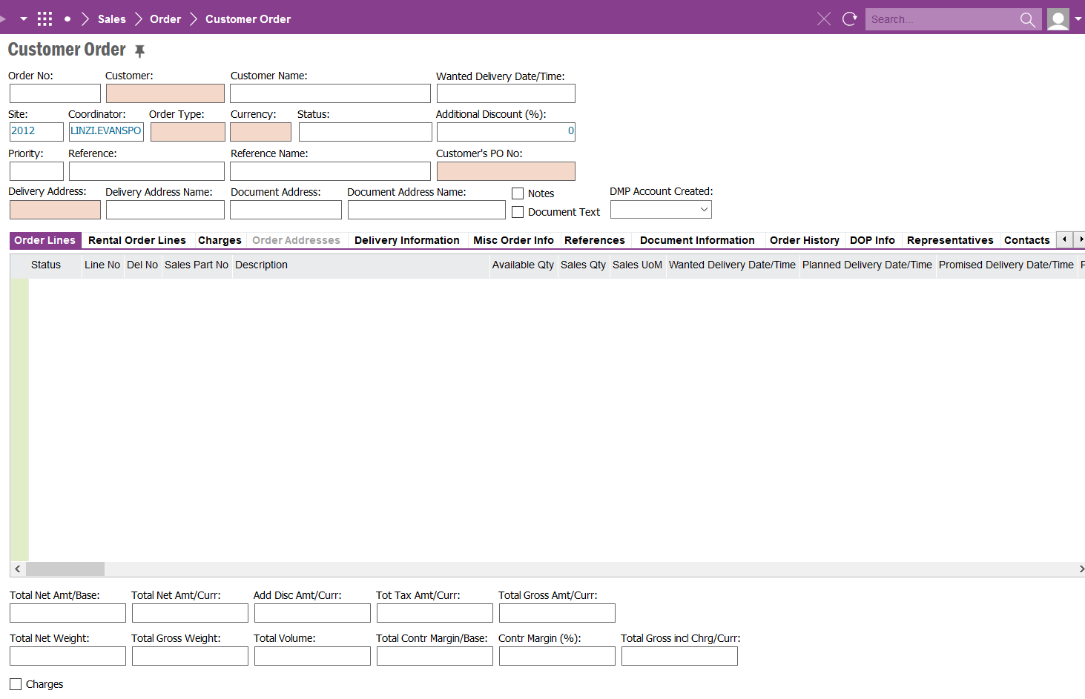

If the Customer Order has been created from a Business Opportunity or a Sales Quotation and the PO Number field is left blank and an attempt is made for the order to be released, an information pop up will appear. The message will read:

Customer PO number has not been entered, are you sure you want to proceed?

If the Customer’s PO Number field has a value, the order will be released.

We must ensure that this CRIM does not affect customer orders that come via a work order or a project.

Field Definitions

<New Field/CLU Definition>

|  |  |  |  |  |  |  |
| --- | --- | --- | --- | --- | --- | --- |
| New DB Object Name | DB Object Item/Field Names | Item Description | Item Data Type | Item Syntax | Calculation Spec, if Derived | LOVs/Enums/Is Mandatory? |
|  |  |  |  |  |  |  |
|  |  |  |  |  |  |  |
|  |  |  |  |  |  |  |
|  |  |  |  |  |  |  |
|  |  |  |  |  |  |  |
|  |  |  |  |  |  |  |
|  |  |  |  |  |  |  |
|  |  |  |  |  |  |  |
|  |  |  |  |  |  |  |
|  |  |  |  |  |  |  |
|  |  |  |  |  |  |  |
|  |  |  |  |  |  |  |

Security

All users with access to Customer Order can access / view and edit this field.

Companies

Applies to the following companies

|  |  |
| --- | --- |
| **Company** | **Required (Y/N)** |
| 1201 | Y |
|  |  |
|  |  |

Data Migration

N/A

Test Steps

<Steps that needs to be taken to test this change. Please provide expected results>

|  |  |  |
| --- | --- | --- |
| **No** | **Script\Test Steps** | **Expected Result** |
| 1 | Convert Sales Quotation to Customer Order | Customer’s PO Number field requires an entry. |
| 2 | Customer Order is created and viewed | Customer PO Number entered in previous step is populated into Customer PO No field on customer order screen. |
| 3 | Customer Order is saved | Information Message Pop Up to remind users to attach PO Document. |
|  |  |  |
|  |  |  |
|  |  |  |

Technical Implementation

This implementation uses following Custom Objects;  
  
Custom Event: CUST_ORD_MANDATORY_PO_NO  
  
